**SECTION A (60 Marks)**

Answer only **three** questions from this section.

1. What is meant by the term transition element? (01 mark)
2. One of the characteristics of transition elements is that of having variable oxidation states.
3. Explain why transition elements have variable oxidation states. (02 marks)
4. Write the possible stable oxidation states exhibited by chromium and manganese. (04 marks)
5. Write the formulae of the oxides of chromium in the oxidation states in (ii) above. (01½ marks)
6. Write equation for the reaction between the oxides of chromium and manganese in their highest oxidation states with:
7. Water. (02 marks)
8. Aqueous potassium hydroxide solution. (02 marks)
9. State what would be observed and write equation for the reaction when: (@02½ marks)
10. A solid mixture of chromium (III) oxide and sodium peroxide were fused.
11. Dilute sulphuric acid was added to potassium manganate (VI) solution.
12. Sulphur dioxide gas was bubbled through acidified potassium dichromate solution.
13. Concentrated sulphuric acid was added to a mixture of benzene and concentrated nitric acid.
14. State what was observed. (01 mark)
15. Write equation and suggest a mechanism for the reaction. (05 marks)
16. The main organic product in (a) was used in preparation of benzene diazonium chloride. Using equations, write the reaction scheme for the process. (05 marks)
17. State what was observed and write the equation for the reaction when benzene diazonium chloride was added to alkaline solution of: (@03 marks)
18. Phenol.
19. Naphthalene-2-ol.
20. Without equations describe how benzene diazonium chloride and potassium cyanide can be used to prepare benzoic acid. (03 marks)
21. State Raoult’s law as applied to miscible liquids. (01 mark)
22. (i) The saturated vapour pressures of pure propanone and trichloromethane at 25ᵒC are 38.5 & 26.7Knm-2 respectively. Calculate the vapour pressure of the solution made by mixing 203g of propanone and 179.5g of trichloromethane at 25ᵒC. [Assuming the solution obeys Raoult’s law] (05 marks)
23. If the vapour pressure of the solution in (i) above is 28.5kNm-2, State how the solution deviates from Raoult’s law. (01 mark)
24. Sketch a labelled boiling point-composition diagram for the mixture of propanone and trichloromethane. [The boiling points of propanone and trichloromethane are 56ᵒC and 61ᵒC respectively]. (03 marks)
25. (i) A hydrocarbon turpentine, C10H16, distills freely in steam at 95ᵒC and at an external pressure of 101325Pa. Calculate the vapour pressure of turpentine at 95ᵒC if the distillate contained 45% water. (04 marks)
26. Mention two ways by which turpentine in the distillate can be isolated. (02 marks)
27. Ethanol and propanoic acid react reversibly and exothermically according to the following equation.
28. Write the expression for the equilibrium constant, KC for the reaction. (01 mark)
29. Describe an experiment that can be used to determine the equilibrium constant for the esterification reaction between ethanol and propanoic acid. (06 marks)
30. State and explain how the equilibrium position and equilibrium constant value,KC or KP would be affected if:
31. 62.1g of ethanol were mixed with 185g of propanoic acid and the mixture allowed to reach equilibrium. Calculate the mass of the ethylpropanoate formed at equilibrium. [KC = 4.00 for esterification reaction] (06 marks)

**SECTION B (40 Marks)**

Answer only **two** questions from this section.

1. . The thermodynamic data about lithium and oxygen are given below

2Li(s) + ½O2(g) Li2O(s) ∆H = -596.0kJ/mol.

Li2O(s) 2Li2+(g) + O2-(g) ∆H = +2,852.8kJ/mol.

Li(s Li(g) ∆H = +161.0kJ/mol.

Li(g) Li+(g) + e- ∆H = +519.0kJ/mol.

O2(g 2O(g) ∆H = +496.0kJ/mol.

O(g)  O-(g) + e- ∆H = -142.0kJ/mol.

1. Draw an energy level diagram for the formation of lithium oxide. (04 marks)
2. Use your diagram in c (i) to calculate the second electron affinity of oxygen gas. (03 marks)
3. Explain what is meant by the term first electron affinity. (02 marks)
4. The table below shows the first electron affinities of period 2 elements of the periodic table.

|  |  |  |  |  |  |  |  |
| --- | --- | --- | --- | --- | --- | --- | --- |
| Elements | 3Li | 4Be | 5B | 6C | 7N | 8O | 9F |
| First electron affinity (kJ/mol) | -52 | +50 | -29 | -120 | -3 | -142 | -348 |

Explain the trend in the electron affinities of period 2 elements. (07 marks)

1. Given the thermodynamic data.

KOH(aq) + HCl(aq) KCl(aq) + H2O(l) -57.3kJ/mol.

H2(g) + ½O2(g) H2O(l)  -285.9kJ/mol.

½H2(g)  + ½Cl2(g) HCl(aq) -164.2kJ/mol.

K(s) + ½O2(g) + ½H2(g) KOH(aq) -487.0kJ/mol.

KCl(s) + (aq) KCl(aq)  +18.4kJ/mol.

Use the data above to calculate the standard enthalpy of formation of potassium chloride. (04 marks)

1. Organic compounds, P and Q have the same molecular formula.
2. Write the structural formulae of the possible isomers of P and Q. (02 marks)
3. When a mixture of sodium nitrite solution and concentrated hydrochloric acid was treated with both P and Q at 5ᵒC, P formed yellow oily compound, R while Q formed a colourless compound, S together with a neutral gas, T. Compound, S was found to form two layers within 8 minutes when treated with anhydrous zinc chloride and concentrated hydrochloric acid.
4. Identify compounds, P, Q, R, S & T. (02½ marks)
5. Write equation for the reaction to show how: (@01 mark)

* Compound, R was formed.
* Compounds, S & T were formed.

1. Write equation and suggest a mechanism for the reaction between:
2. Compound, P and ethanoylchloride. (03½ marks)
3. Compound, Q and bromoethane. (03 marks)
4. Compound, S and ethanoic acid in the presence of concentrated sulphuric acid and the mixture was heated. (04½ marks)
5. Compound, S was warmed with acidified chromium trioxide solution.
6. State what was observed. (01 mark)
7. Write equation for the reaction and name the main organic product. (01½ marks)
8. Write the formulae of the hydrides of period 3 elements of the periodic table. (03½ marks)
9. Write equation to show how the hydrides of the following elements are prepared in the laboratory. (@01½ marks)
10. Sodium.
11. Silicon.
12. Sulphur.
13. Discuss the reactions of the hydrides in (b) above with:
14. Sodium hydroxide solution. (02½ marks)
15. Concentrated sulphuric acid. (02½ marks)
16. State what would be observed and write equation for the reaction when the hydride of sulphur is burnt in: (@02 marks)
17. Limited air.
18. Excess air.
19. Briefly describe a simple chemical test that can be carried out to show that sodium hydride is an ionic compound. (03 marks)
20. Explain the following observations.
21. Concentrated sulphuric acid cannot be used in the preparation of hydrogen iodide from potassium iodide. (05 marks)
22. When dilute sulphuric acid was added to copper (I) oxide, the red solid turned brown and a blue solution was formed. (04 marks)
23. When iron (III) chloride solution was added to sodium ethanoate solution, red-brown solution was formed which turned to reddish-brown precipitate on heating. (04 marks)
24. The boiling points of propylamine and trimethylamine are 48.6 & 3.5ᵒC respectively.
25. Sulphurous acid is a weaker acid than sulphuric acid. (03 marks)

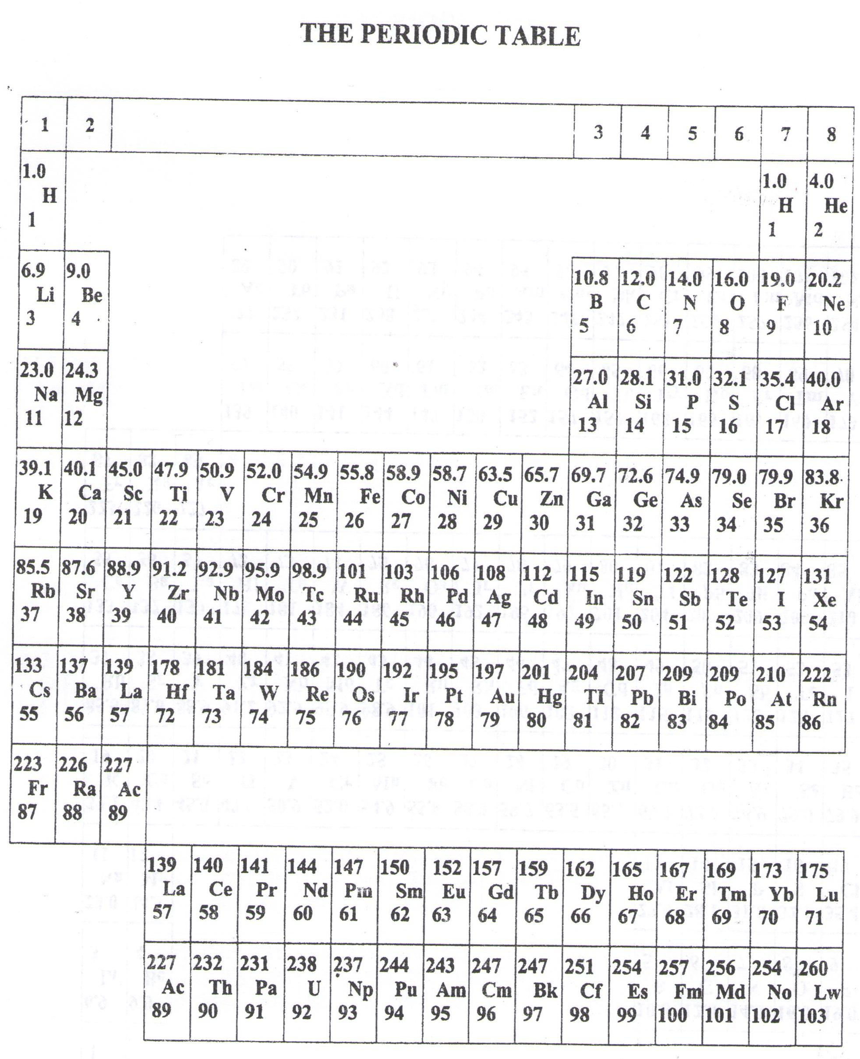

* ===END===

WELCOME TO SENIOR SIX, YEAR 2023

This is the last page of the printed paper, Page 07